Change Move-In Date in Yardi
Objective
This SOP outlines the steps to manage tenant move-in dates that differ from the standard lease start date, ensuring all necessary adjustments are made in the system.
Key Steps

Step 1: Access the Prospect Page 0:00
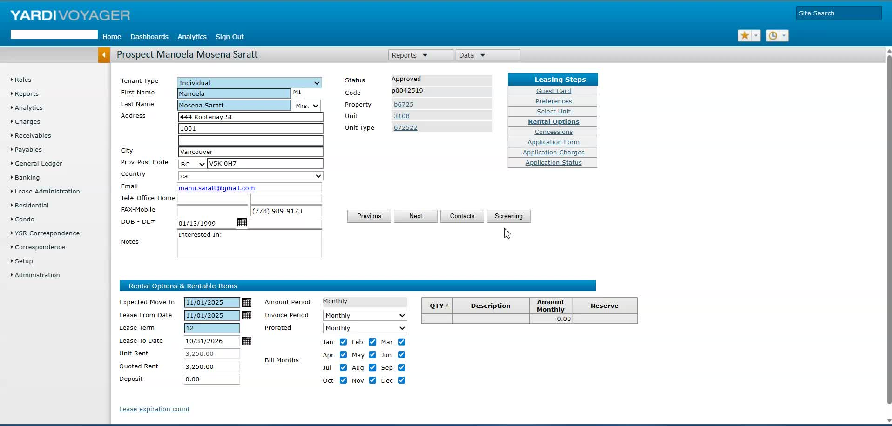
- Navigate to the prospect page in the system.
- Confirm the tenant's approved move-in date (e.g., November 15th for Manola and Matthew).

Step 2: Check System Lock Status 0:28
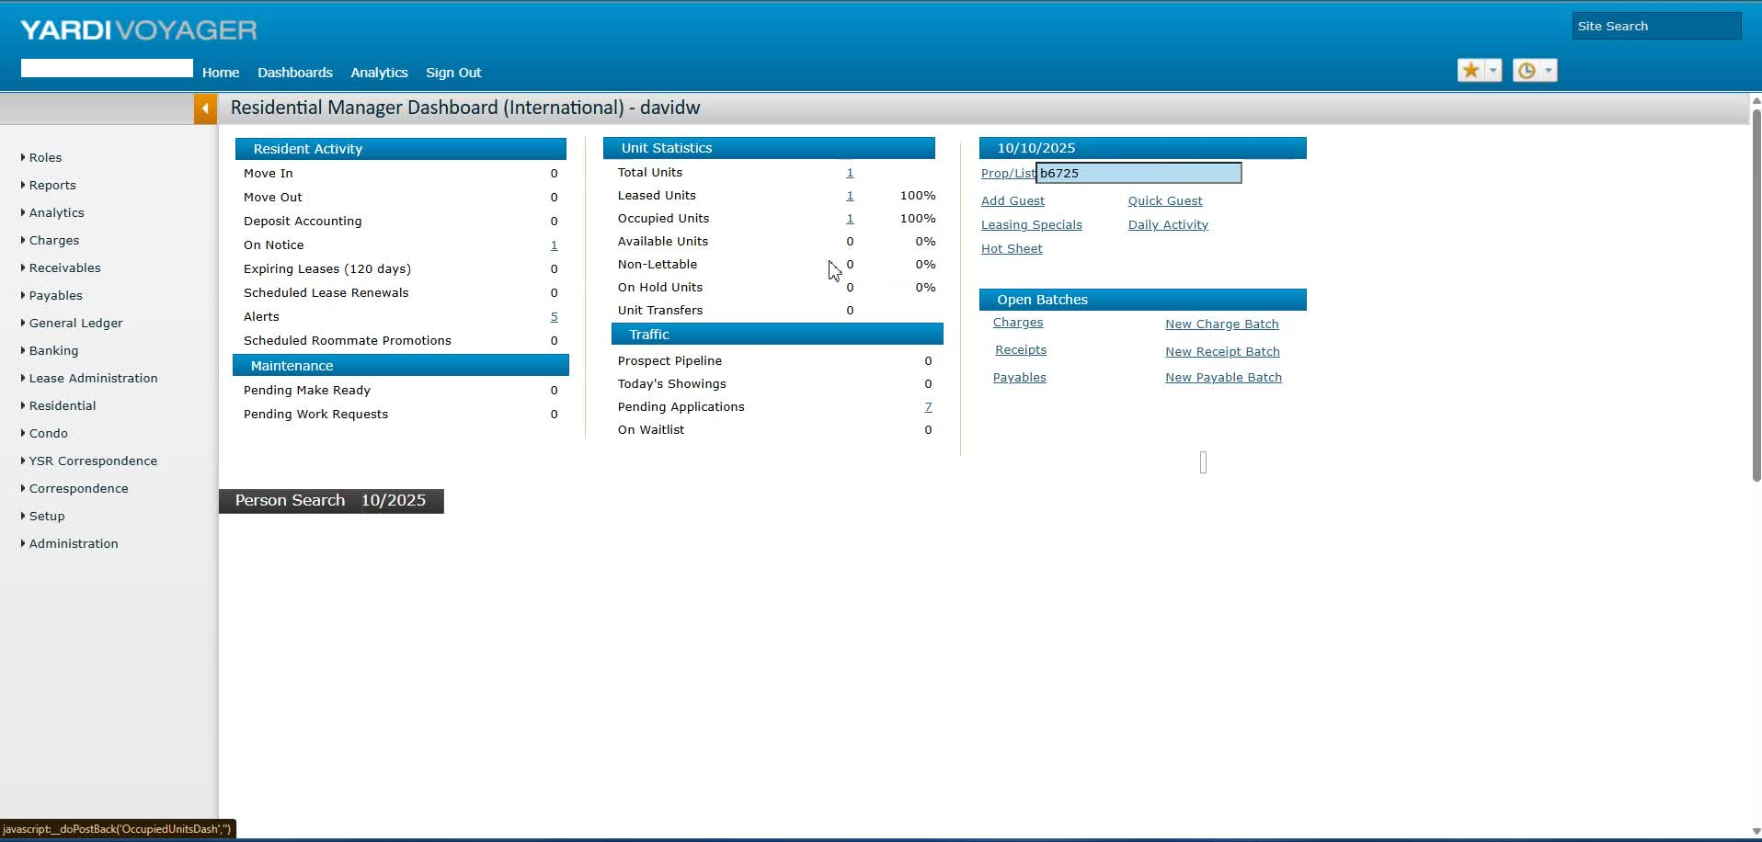
- Verify if the back office is locked.
- Note that changes cannot be made if the back office is locked.

Step 3: Navigate to Pending Applications 0:42
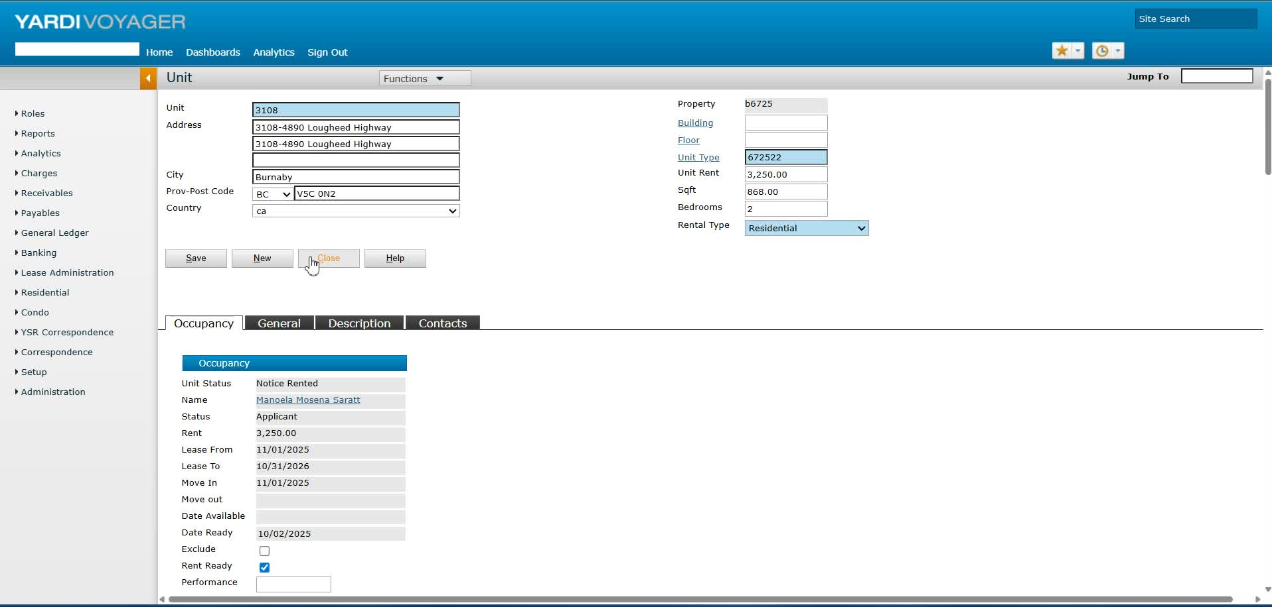
- Go to the property page.
- Select 'Pending Applications' to access the relevant tenant application.

Step 4: Update Move-In and Lease Dates 0:54
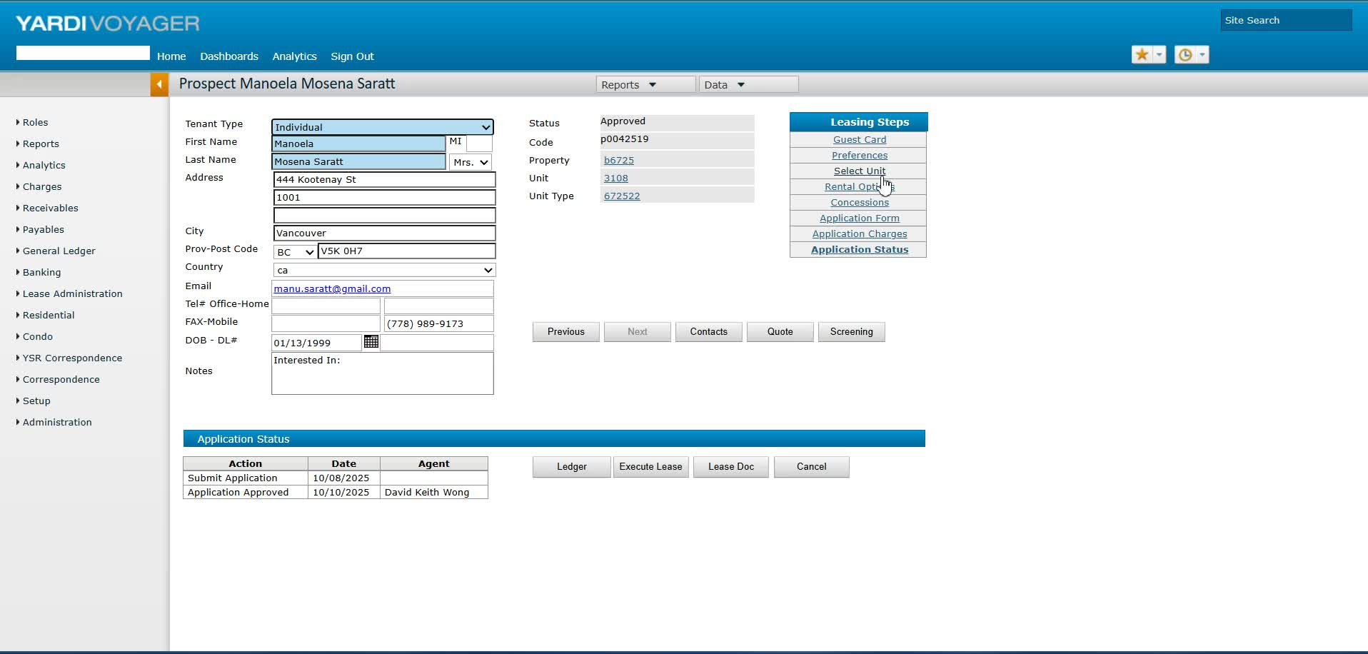
- In the rental options, set the expected move-in date to November 15th.
- Set the lease end date to November 30th of the same year.

Step 5: Confirm Rent Payment Terms 1:08
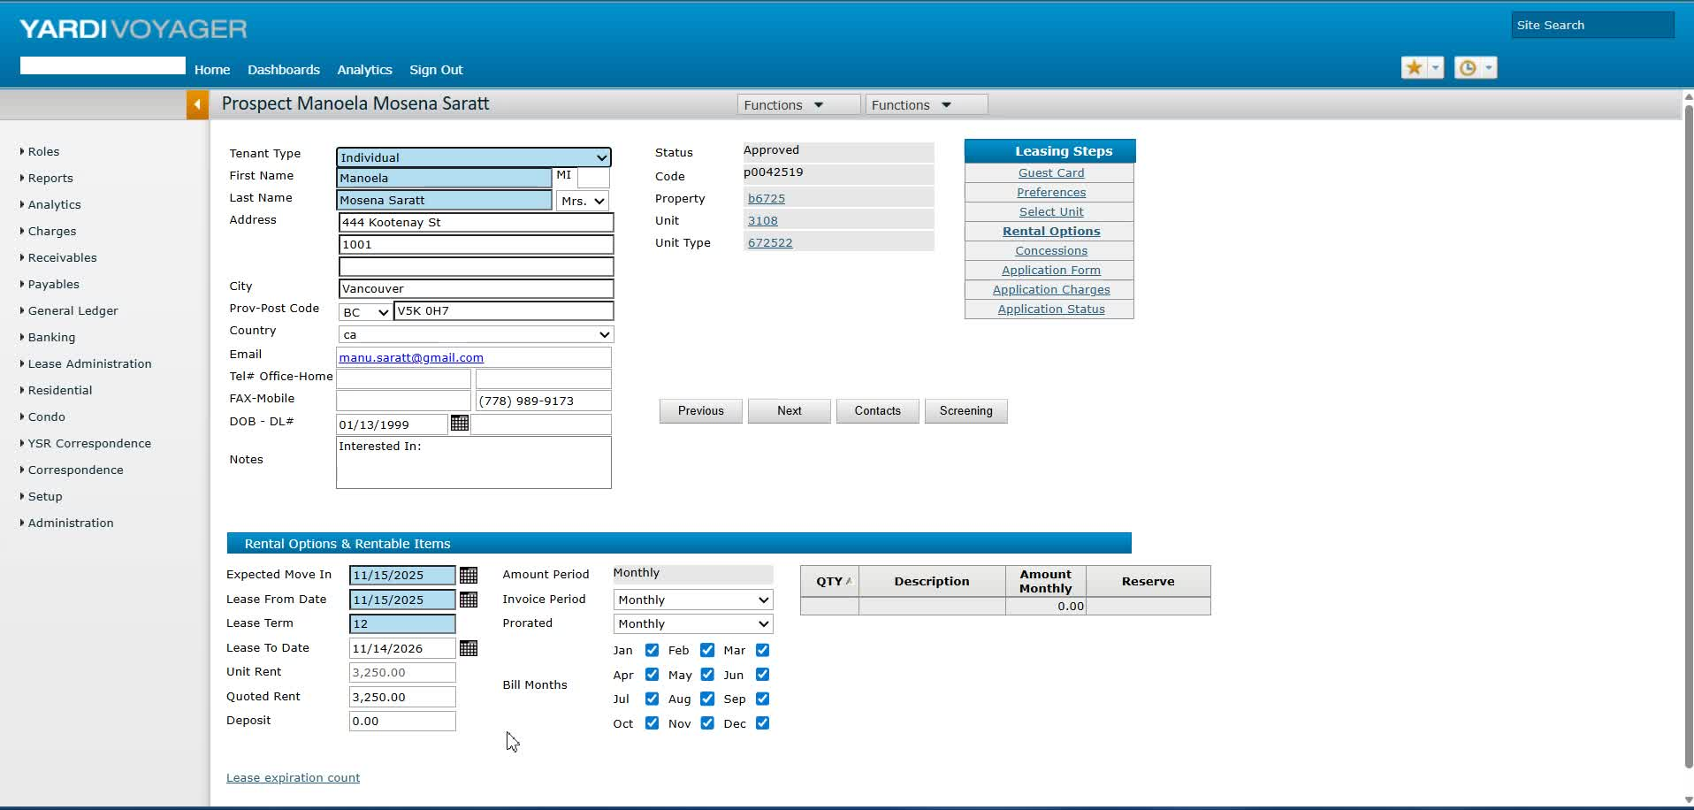
- Ensure that the tenant is aware they will pay the full month of November rent regardless of the move-in date.

Step 6: Review Application Charges 2:00
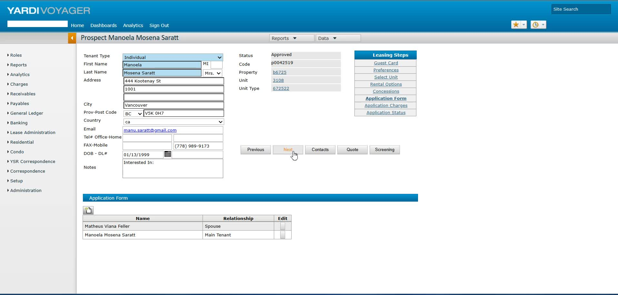
- Check the application charge details to ensure accuracy before generating the tenancy agreement.

Step 7: Verify Tenant Information 2:33
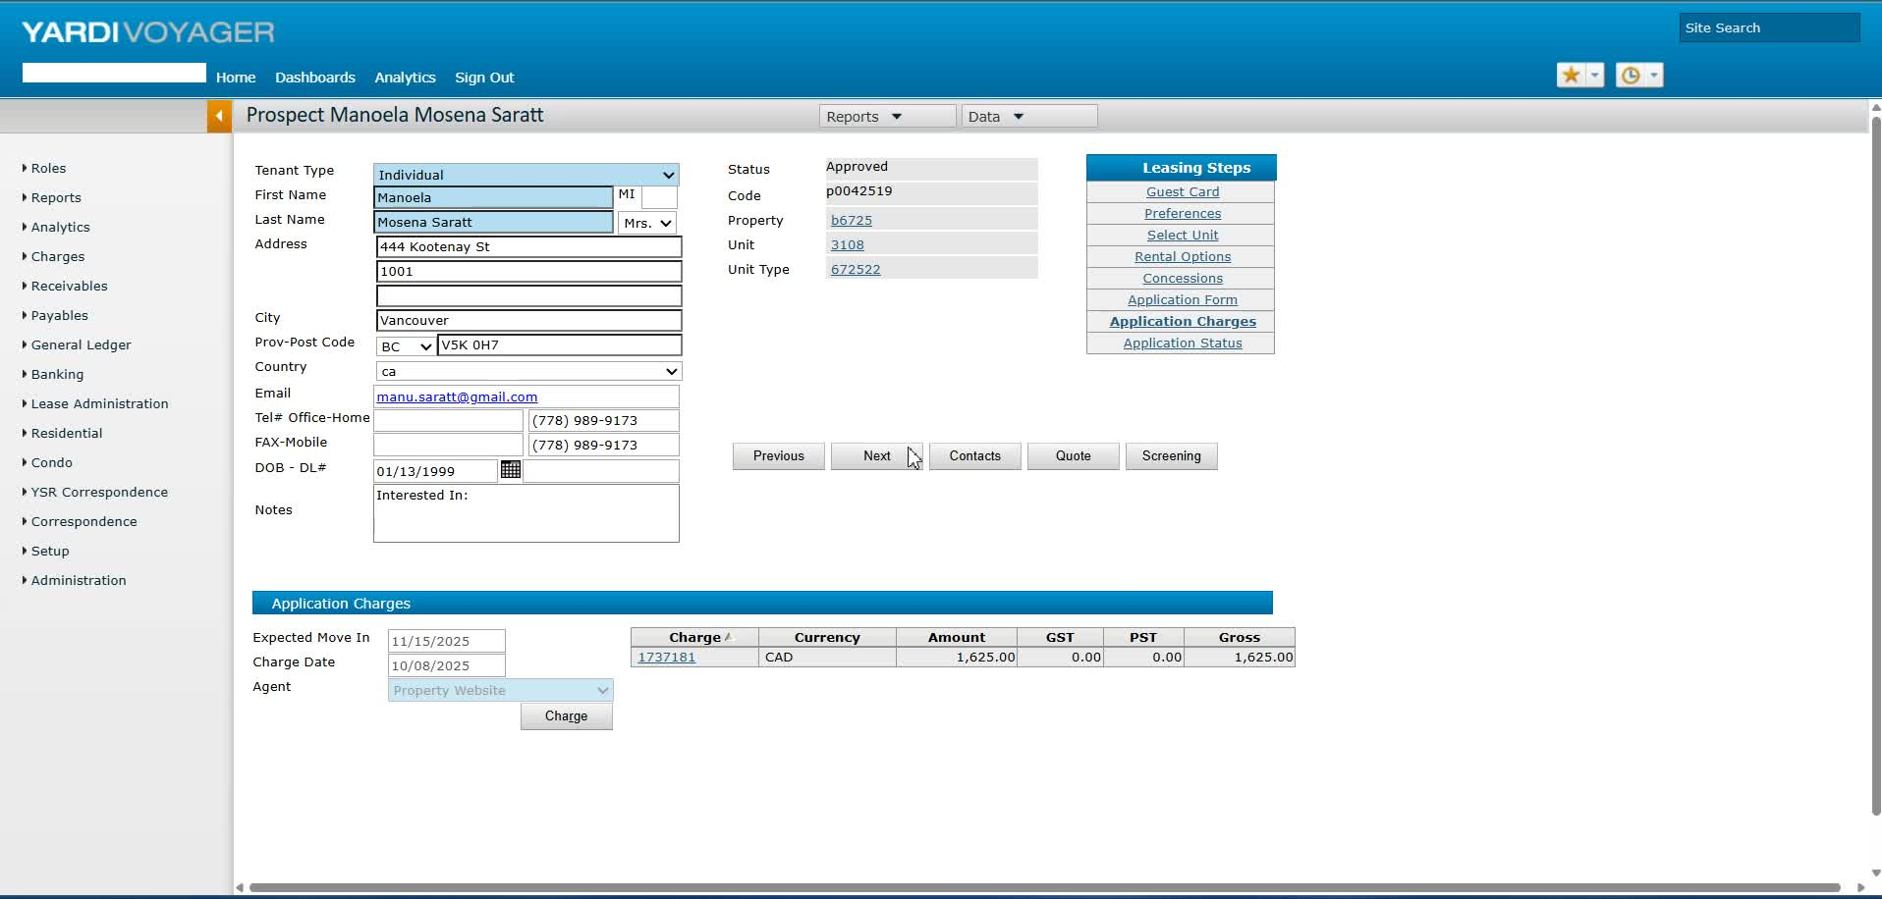
- Confirm that all tenant information, including phone numbers, is correctly saved in the system.

Step 8: Access RENCAFE for Updates 3:08
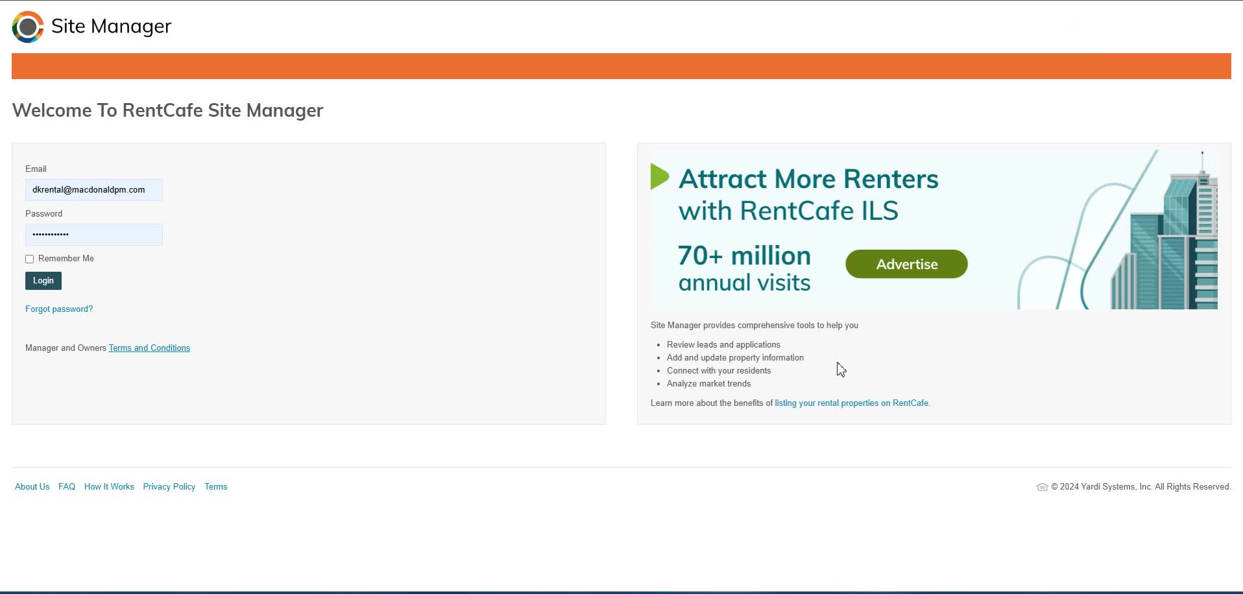
- Launch RENCAFE and access the tenant's profile.
- Ensure that the move-in date reflects the updated date.

Step 9: Generate Tenancy Agreement 4:00
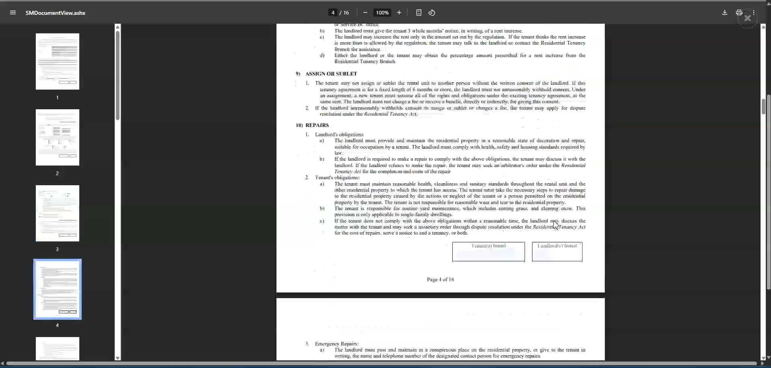
- Generate the tenancy agreement ensuring all details are correct, including phone numbers and email addresses.

Step 10: Final Review and Save 5:08
- Conduct a final review of all documents, including parking and storage agreements.
- Save all documents in the designated subfolder for signature preparation.
Cautionary Notes
- Always double-check tenant information for accuracy before finalizing documents.
- Ensure that the back office is not locked before attempting to make changes.
Tips for Efficiency
- Use templates for tenancy agreements to save time.
- Regularly update tenant information to avoid discrepancies during the process.
Link to Loom
https://loom.com/share/d0b7b718db7b45a1a4c7c500ff9cdaff

